Bahria University,

Karachi Campus



LAB EXPERIMENT NO.

___04___

LIST OF TASKS

|  |  |
| --- | --- |
| TASK NO | OBJECTIVE |
| **01** | Make a Calculator! using prompt(), and variables, make a program that does the following:  i Prompts the user for first number.  ii Stores that first number  iii Prompts the user for the second number  Iv Asks which operation does it want to perform (+,-,/,*,++,--,%) |
| **02** | Guess the number game !  I take user input to check age of the student  II use function checkage(age) to see if person is eligible to play or not. If age is greater or equal to 18 then one can proceed otherwise “you’re underage” will be prompted and game will be ended.  III if the person is eligible he will be asked to guess a constant number that you must have already stored.  IV take user input to compare users guessed value with your constant number if that’s the same value prompt as “ you win” otherwise “you lose |
| **03** | Alarm ringing !  I Suppose by default there is a prompt saying “ Alarm is ringing”. Press ‘S’ to snooze and ‘D’ to dismiss  II If user selects ‘D’, program will be dismissed with a prompt “Good Morning”  III If user select ‘S’ , the program “ Alarm is ringing”. Press ‘S’ to snooze and ‘D’ to dismiss will rerun and again the prompt will be (repeat from step I)  IV upon entering wrong input program will prompt “wrong input” and program ends. |
| 04 | Create an object and an array which we will use in our facebook exercise.   * Create an object that has properties "username" and "password". Fill those values in with strings. * Create an array which contains the object you have made above and name the array "database". |

Submitted On

19-10-2023

(Date: DD/MM/YY)

**Task 01:** Make a Calculator! using prompt(), and variables, make a program that does the following:

i Prompts the user for first number.

ii Stores that first number

iii Prompts the user for the second number

Iv Asks which operation does it want to perform (+,-,/,*,++,--,%)

V Stores that result and responds with the calculated value by using an alert.

**Solution:**

let num1 = +prompt("Enter First Number");let num2 = +prompt("Enter Second Number");let opt = prompt("Enter Operator (+,-,/,*,++,--,%");if (opt === "+") { alert(`The Addition of ${num1} and ${num2} is ${num1 + num2}`);} else if (opt === "-") { alert(`The Subtraction of ${num1} and ${num2} is ${num1 - num2}`);} else if (opt === "*") { alert(`The Multiplication of ${num1} and ${num2} is ${num1 * num2}`);} else if (opt === "/") { alert(`The Division of ${num1} and ${num2} is ${num1 / num2}`);} else if (opt === "++") {alert(`The Increment of ${num1} and ${num2} is ${num1+1}`);} else if (opt === "--") {alert(`The Decrement of ${num1} and ${num2} is ${num1-1}`);}else {alert("Enter correct operator");}

**Output:**

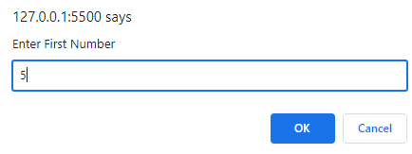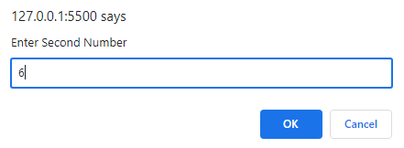

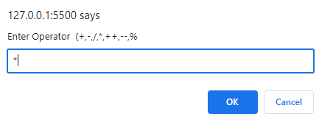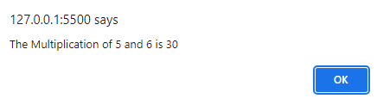

**Task 02:** Guess the number game !

I take user input to check age of the student

II use function checkage(age) to see if person is eligible to play or not. If age is greater or equal to 18 then one can proceed otherwise “you’re underage” will be prompted and game will be ended.

III if the person is eligible he will be asked to guess a constant number that you must have already stored.

IV take user input to compare users guessed value with your constant number if that’s the same value prompt as “ you win” otherwise “you lose

**Solution:**

let age = +prompt("Enter your Age");let myNum = 16,userNum;

function checkAge() {if (age >= 18) {userNum = +prompt("Enter your guess Number");if (userNum === myNum) {alert("You win");}else {alert("You lose");}} else {alert("You are underage"); }}checkAge();

**Output:**

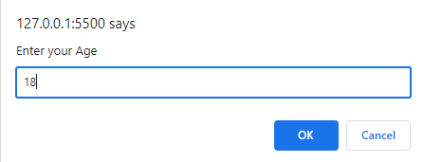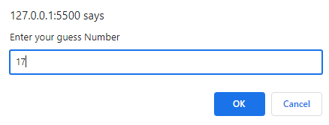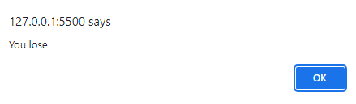

**Task 03:** Alarm ringing !

I Suppose by default there is a prompt saying “ Alarm is ringing”. Press ‘S’ to snooze and ‘D’ to dismiss

II If user selects ‘D’, program will be dismissed with a prompt “Good Morning”

III If user select ‘S’ , the program “ Alarm is ringing”. Press ‘S’ to snooze and ‘D’ to dismiss will rerun and again the prompt will be (repeat from step I)

IV upon entering wrong input program will prompt “wrong input” and program ends.

**Solution:**

function question() {let userInput= prompt("Alarm is ringing Press S to snooze and D to dismiss");if (userInput === "S" || userInput==="s") {question();} else if (userInput === "D" | userInput==="d") {alert("Good Morning");}else {alert("Wrong Letter")}}question()

**Output:**

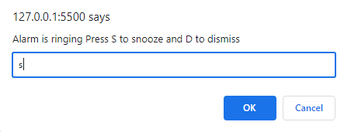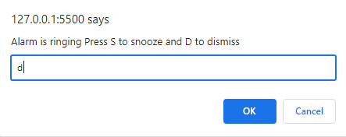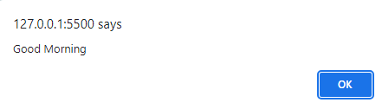**Task 04:** Create an object and an array which we will use in our facebook exercise.

* Create an object that has properties "username" and "password". Fill those values in with strings.
* Create an array which contains the object you have made above and name the array "database".
* Create an array called "newsfeed" which contains 3 objects with properties "username" and "timeline".

**Solution:**

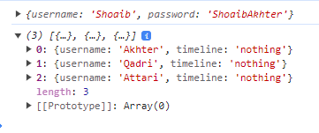let database=[ info = { username: "Shoaib", password:"ShoaibAkhter",}]let newsfeed = [{ username: "Akhter", timeline: "nothing" }, { username: "Qadri", timeline: "nothing" },{ username: "Attari", timeline: "nothing"},];console.log(database[0]);console.log(newsfeed)

**Output:**